(14 pt) Title of Your Paper, Capitalize First Letter (Times New Roman)
(12pt) First Author¹*, Second Author², Third Author²
(10pt)¹ Automotive Technology Center (ATeC), Politeknik Sultan Mizan Zainal Abidin, 23000 Dungun, Terengganu
²Department of Mechanical Engineering, Politeknik Sultan Mizan Zainal Abidin, 23000 Dungun, Terengganu (10pt) *Corresponding author E-mail: abc@psmza.edu.my
Abstract
Times New Roman, font size 10pt, single line spacing, and maximum 200 words in a single paragraph. Please include objectives, methods, results, and conclusions in the abstract.
Key Words: Include up to six keywords for indexing and database word searches. Please separate keywords by semicolons

Introduction
The minimum pages required are 6 pages and cannot exceed 10 pages (including references). This document is a template of Microsoft Word version 2013 document. Please save your paper in a Microsoft Words format. The paragraphs continue from here and are only separated by headings, subheadings, images, formulas, and equations and 6pt spacing after the text.

Formatting the text
The text of your paper should be formatted as follows:

- 12-point Times New Roman.
- The text should be set to single-line spacing.
- Paragraphs should be justified.
- The first paragraph after a section or subsection heading should not be indented; subsequent paragraphs should be indented by 5 mm.
- Single tab for all paragraph

Page Setup
The top margin (2.54 cm/1 inch), bottom (2.54 cm/1 inch), left (2.54 cm/1 inch); and right (2.54 cm). Papers should be printed on A4 size paper (21 x 29.7 cm).

Structure
The file should be prepared in Microsoft Word format only and should be ready for printing. Figures, tables, and equations must be embedded in the text. Make sure that author uses Times New Roman in the whole document write-up. Full–length article should follow this order: Title, Authors name and affiliation, Corresponding authors email, Abstract, Keywords, Introduction, Materials and Methods, Results and discussions, Conclusion, Acknowledgement, References, and Appendix (optional).

Section Headings
Section heading should be left justified, capitalized, bold, 12 pt., 6 pt. spacing before and after, and numbered consecutively, starting with the Introduction. Sub-section headings should be in the capital for the first letter and numbered 1.1, 1.2, etc., and left justified like the example above.

4.1 Sub-Section Headings

Tables
All tables should be numbered with Arabic numerals. Headings should be placed above tables (in bold letters), left justified, 6 pt. spacing before and after, and single line spacing. Only horizontal lines should be used within a table, to distinguish the column heading from the body of the table, and immediately above and below the table. Tables must be embedded into the text and not supplied separately. The head of the table should be centered unless they occupy the full width of the text. Table rules should be 0.5 points wide.
Examples
(12pt) Table 1: An example of a table
Variable | Sample A | Sample B | OR (95% CI) | ², p-value
(10 pt) | (10 pt) | (10 pt) | (10 pt) | (10 pt)
(10 pt) | (10 pt) | (10 pt) | (10 pt) | (10 pt)
(10 pt) | (10 pt) | (10 pt) | (10 pt) | (10 pt)

More complex tables:
(12pt) Table 2: A slightly more complex table with a caption that is the same width as the table. Simply place the caption inside a row at the top of the table and merge (combine) the cells together so that you have a single table cell the width of the table. Justify the caption.

 | Wake Chi Sqr. (N=15, df=1) | p | Stage 1 Chi Sqr. (N=15, df=1) | p | Stage 2 Chi Sqr. (N=15, df=1) | p
F3 | 1.143 | 0.285 | 0.286 | 0.593 | 0.286 | 0.593
Fz | 1.143 | 0.285 | 0.067 | 0.796 | 0.067 | 0.796
Cz | 1.143 | 0.285 | 0.077 | 0.782 | 0.286 | 0.593

Figures
All figures should be numbered with Arabic numerals. All photographs, graphs and diagrams are to be referred to as figures. Line drawings should be good quality, low-quality scans are not acceptable. Figures must be embedded into the text and not supplied separately. Figures should be placed at the top or bottom of a page wherever possible, as close as possible to the first reference to them in the paper.
In general, try to avoid extremely fine lines (often called ‘hairline’ thickness) because such lines often do not reproduce well when printed out—your diagrams may lose vital information when downloaded and printed by other researchers. Try to ensure that lines are no thinner than 0.25 pt. Note that some illustrations may reduce line thickness when the graphic is imported and reduced in size (scaled down) inside Microsoft Word.

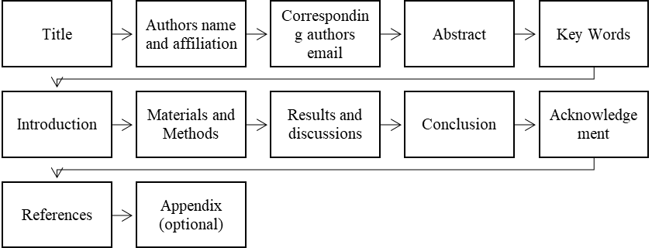
(12pt) Figure 1: Structure of the article

(Maximum size H 2.3 x W 3.4) Figure 2: In this case simply justify the caption so that it is as the same width as the graphic.
(Maximum size H 2.3 x W 2.17) Figure 3. These two figures have been placed side-by-side to save space. Justify the caption. |  | Figure 4. These two figures have been placed side-by-side to save space. Justify the caption.

Equations
The equations and formula should be typed and numbered consecutively with Arabic numerals in parentheses on the centre of the page and should be placed inside a hidden table. The use of Microsoft word tools (Equation and Symbols are highly recommended for writing equations). When referring to an equation in the text, always put the equation number in brackets—e.g., ‘as in equation (2)’ or ‘as in equation (2.1)’—and always spell out the word ‘equation’ in full, e.g., ‘if equation (5) is factorized’; do not use abbreviations such as ‘eqn.’ or ‘eq.’.
 | 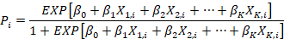 | (1)

References
References should be listed at the end of the paper. Authors should ensure that every reference in the text appears in the list of references and vice versa. References for the journal, books, electronic book, chapter in the book, chapter the electronic book, proceedings and the online document is according to American Psychological Association (APA) version 7 style. Please refer to for further details about organizing the references.

Example format for guidance for APA Style 7th edition
Adams, M., & Kelvin, C. (2001). How to be a millionaire. Kuala Lumpur: Penerbit Fajar
Bakti.
Adams, M., Henry, T., & Gerrard, S. (2014). Language and education. London: McGraw-
Hill.
Angeli, E. L. (2012). Networks of communication in emergency medical services (Publication
No. 3544643) [Doctoral dissertation, Purdue University]. ProQuest Dissertations Publishing.
Armstrong, D. (2019). Malory and character. In M. G. Leitch & C. J. Rushton (Eds.), A new
companion to Malory (pp. 144-163). D. S. Brewer.
Axelrod, A. (2019, August 11). A century later: The Treaty of Versailles and its rejection of
racial equality. Medium. https://www.medium.com/2019/08/11/742293305/acentury-
later-the-treaty-of-versailles-and-its-rejection-of-racial-equality
Baniya, S., & Weech, S. (2019). Data and experience design: Negotiating community-
oriented digital research with service-learning. Purdue Journal of Service-Learning
and International Engagement, 6(1), 11–16. https://doi.org/10.5703/1288284316979
Covey, S. R. (2013). The 7 habits of highly effective people: Powerful lessons in personal
change. Simon & Schuster.
Covey, S. R. (2020). The 7 habits of highly effective people: Powerful lessons in personal
change (5th ed.). Simon & Schuster.
Huang, S., Pierce, R., & Stamey, J. (Eds.). (2006). Proceedings of the 24th annual ACM
international conference on the design of communication. ACM Digital Library. https://dl.acm.org/citation.cfm?id=1166324&picked=prox
National Alliance on Mental Illness. (n.d.). Mental health conditions. NAMI Portal.
https://www.nami.org/Learn-More/Mental-Health-Conditions
Tan, K. M. (2020, March 7). Majority of students are not happy with online learning. The
Star. https://www.thestar.com.my/education/123.
Who Health Organisation. (2013). The diabetes statistics of the world. Brooklyn,NY:WHO
Press.

